Practical-8
MySQL Schema Design, ER Model, PDO Connectivity, and Prepared Statements
Theory
1. Is the schema normalized properly?
Answer: Yes. The StudentHub database uses three separate tables: students, events, and registrations. Student details and event details are stored only once. The registrations table connects them using student_id and event_id, reducing duplicate data and following the basic principles of Third Normal Form (3NF).
2. Are primary keys and foreign keys correctly defined?
Answer: Yes. student_id is the primary key of students, event_id is the primary key of events, and registration_id is the primary key of registrations. The registrations table contains student_id and event_id as foreign keys. A unique constraint prevents a student from registering for the same event twice.
3. Is the database connection handled securely?
Answer: The PHP application uses PDO (PHP Data Objects) to connect to MySQL. Database errors are handled using exceptions, and user input is inserted through prepared statements instead of joining input directly into SQL queries. Database connection settings are stored separately in db.php.
4. How are event registrations stored and tested?
Answer: The application provides student and event dropdowns. After selecting both values, PHP executes a PDO prepared INSERT statement. The result can be checked on the page and in phpMyAdmin under the registrations table.
Result:
The StudentHub MySQL database was created and connected successfully using PHP PDO. Three tables were created with correct relationships and sample data. A new event registration was saved and verified in MySQL. The database contains 15 students, 15 events, and 7 registrations.
Evidence of Work (Screenshots)
Screenshots of the database structure, PDO connection, event registration, saved records, and ER diagram are provided below.

Evidence of Work (Screenshots)
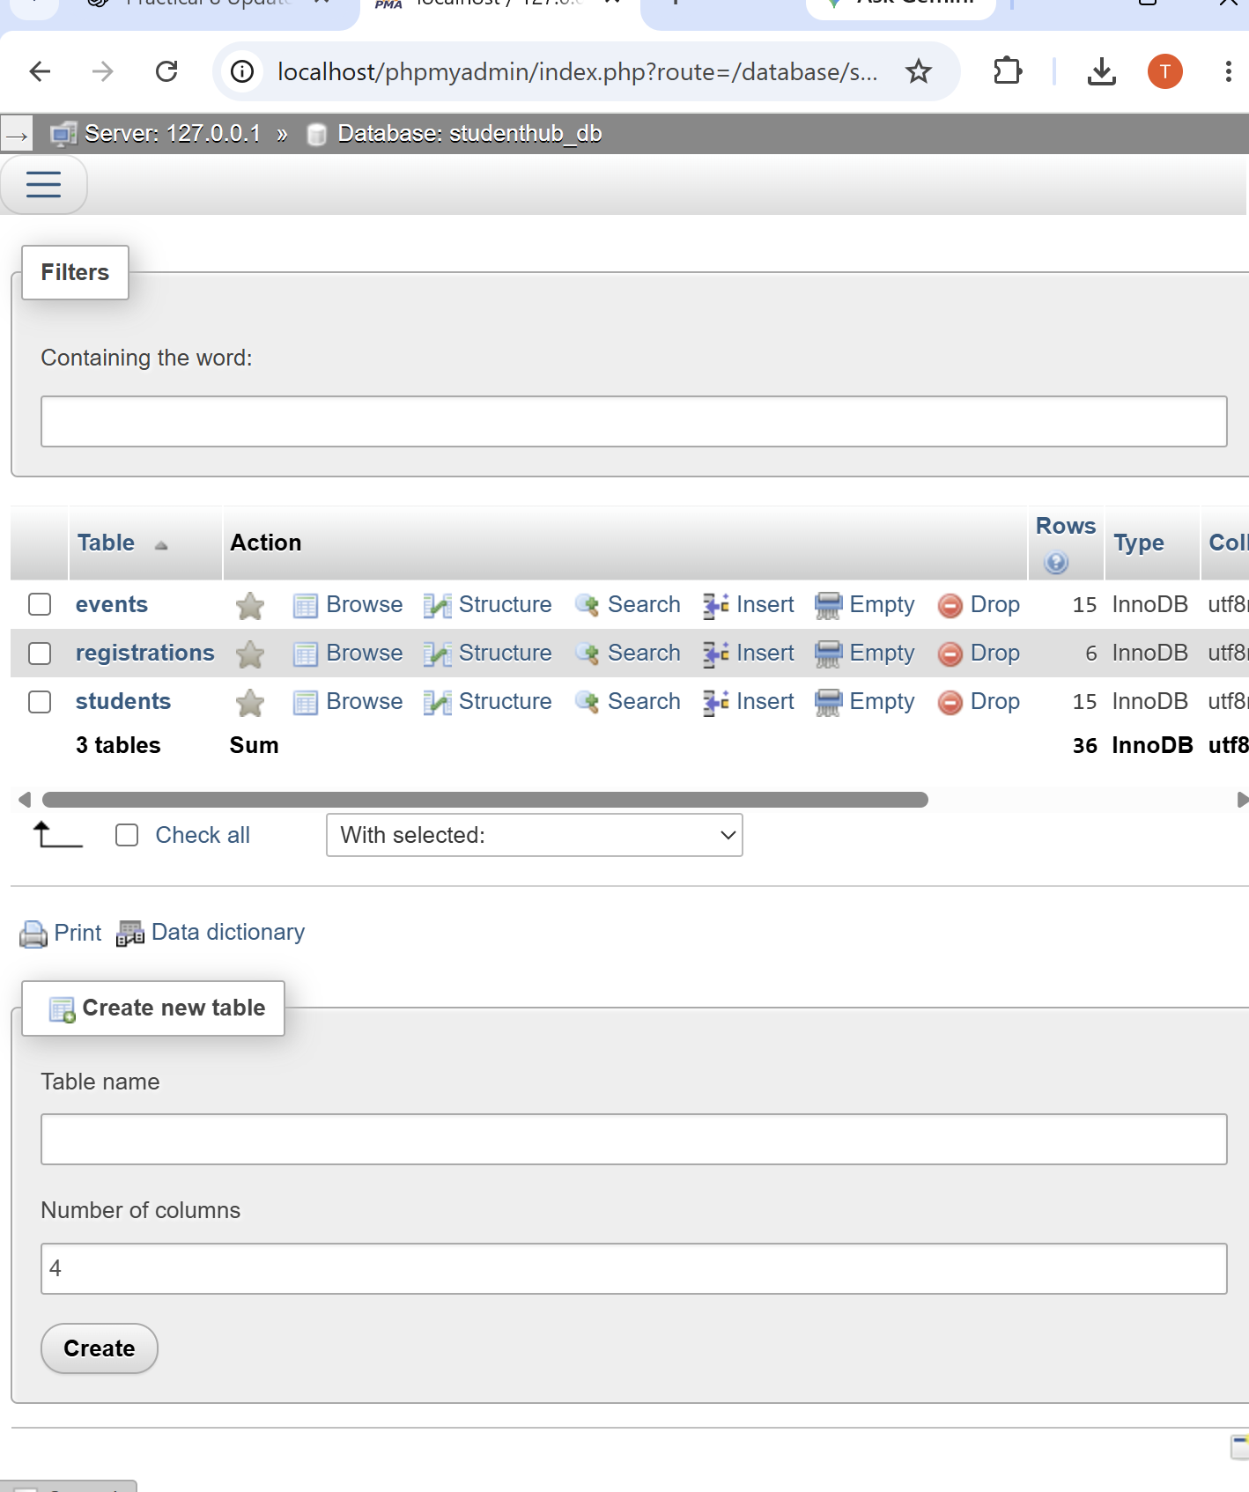
Figure 1: StudentHub Database Structure – Students, Events and Registrations
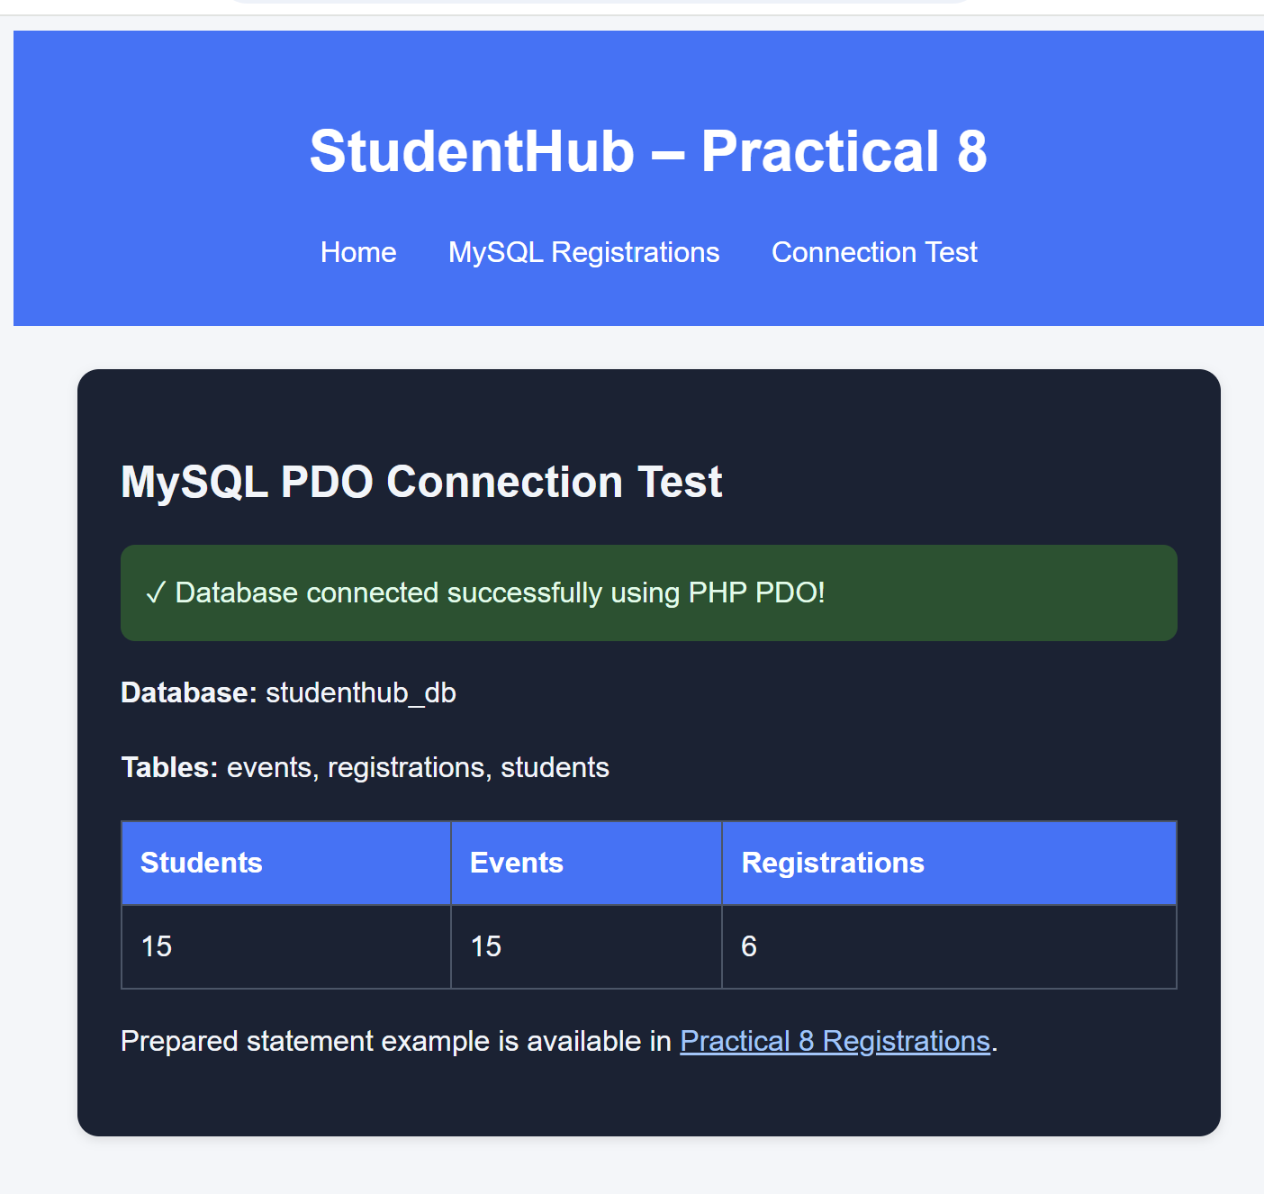
Figure 2: PHP PDO Connection Test – Database Connected Successfully

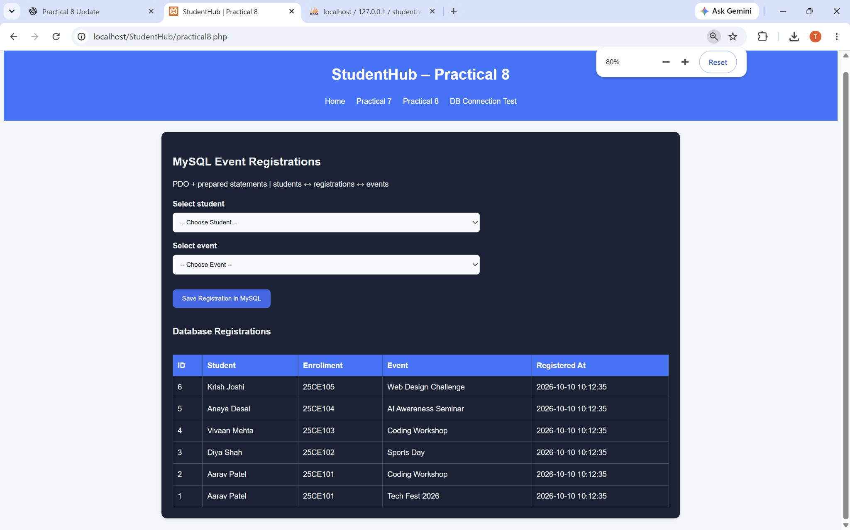
Figure 3: Practical 8 – MySQL Event Registration Form
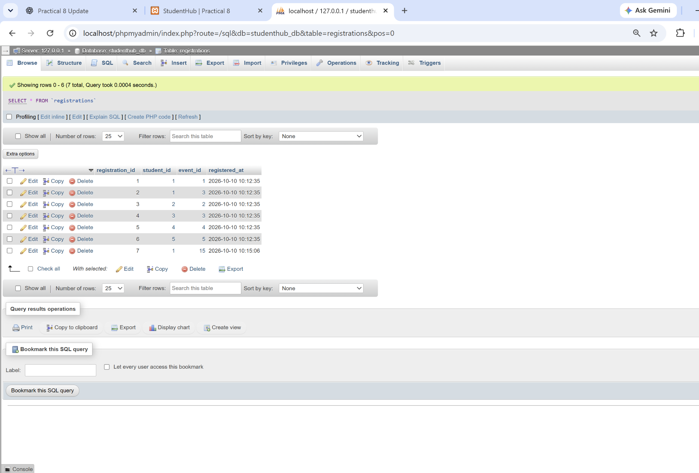
Figure 4: Registration Record Saved in MySQL (7 Total Records)

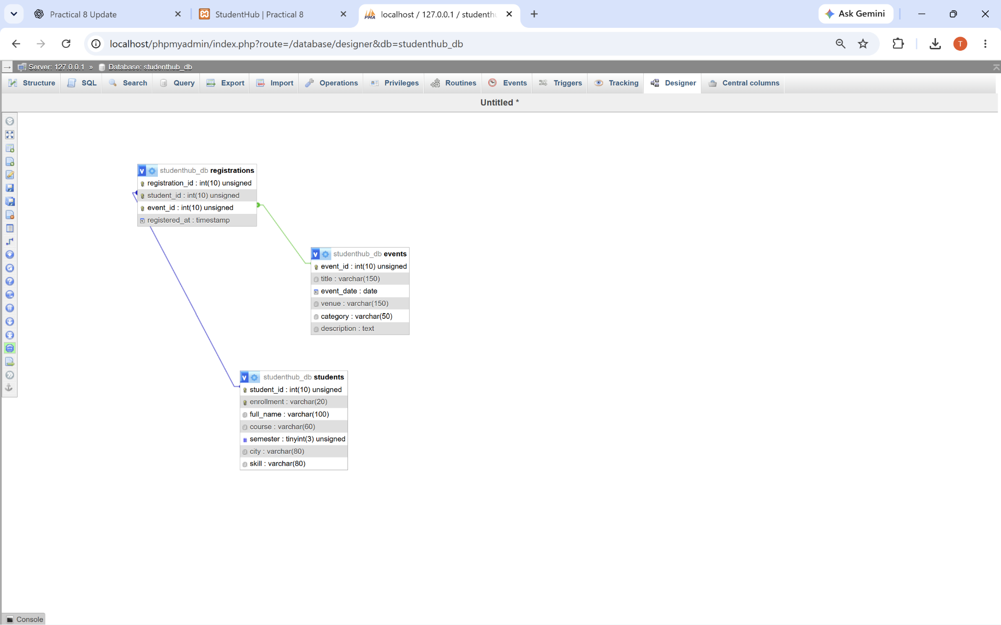
Figure 5: ER Model in phpMyAdmin Designer (PK and FK Relationships)
A. GitHub Repository Link:
https://github.com/adrojatarang8-art/StudentHub
B. Challenges Faced:
- I faced some difficulty while creating the students, events, and registrations tables in MySQL.
- At first, I selected the complete ZIP file for import instead of the studenthub_db.sql file.
- I got a “No database selected” message while importing SQL, so I checked the database and tables again.
- Understanding primary keys, foreign keys, and relationships in the ER model was a little difficult.
- Connecting PHP with MySQL using PDO and testing prepared statements required careful checking.
C. Learning Outcome:-
I learned how to design a normalized database using MySQL and phpMyAdmin.
I understood primary keys, foreign keys and relationships through the ER model.
I learned how to connect PHP to MySQL using PDO and use prepared statements to save registration data securely.
Faculty Remarks:

